 | ELK AWARD  Application |  | 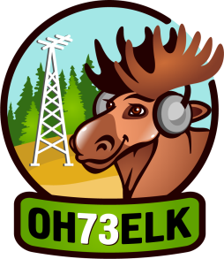
Award Application for the ELK AWARD  Award manager: YL RAISA https://Raisa.blog/ |  | Please accept my application and send the ELK AWARD to  Name:  Call:  Postal address: (only if you would like to receive a printed version by mail and you indicated printed in the Email subject with this Application)

No. | CALL | DATE | UTC | MHz | MODE | REMARKS*
1
2
3
4
5
6
7
8
9
10
11 | OH73ELK

Date: ________

